Name: Sujitha S

Branch: BE CSE(2nd yr)

Milestone 1-completed

Milestone 2 – U-Net:

Train images – 20

Test images – 5

IoU score – 0.2909

Dice score – 0.4213

YOLO detection :

Train images – 20

Test images – 5

IoU (mAP@0.5) – evaluated using pretrained YOLOv5 model

Dice score – Not applicable (YOLO is bounding-box based)

Dataset Collection and Preparation (Weeks 1–2):

**Week** 1(Day 1)

I started the project and looked for good sources of satellite and drone images. I used Google Earth Pro and OpenAerialMap. I also decided the labels: Ruins, Vegetation, Artifacts, and Background Terrain. I checked which areas to focus on and noted some small challenges like shadows and unclear spots.

Websites Used:

[Google Earth Pro](https://www.google.com/earth/versions/earthpro)

[OpenAerialMap](https://openaerialmap.org)

Week 1(Day 2)

I explored the dataset platforms in more detail and checked the type of imagery they provide. I compared the resolution, terrain visibility, and clarity of different websites to understand which sources are most suitable for ruins, vegetation, and artifact analysis. I also reviewed how these images can be used later for annotation and model training. This helped me understand the strengths of each website and plan which datasets to download next.

Websites Checked:

OpenAerialMap:

<https://openaerialmap.org/>

Google Earth Pro (Download page)

<https://www.google.com/earth/about/versions/>

**Week 1**(Day 3)

Start identifying exact locations to collect images for each label (Ruins, Vegetation, Artifacts, Background Terrain).

### **What I did :**

* I selected a few specific locations from the websites I explored earlier.
* I focused on places where ruins and vegetation are clearly visible from satellite images.
* I checked each location on Google Earth Pro to see the clarity and zoom level.
* I marked areas that are suitable to download later for annotation and model training.
* I also noted which labels (Ruins, Vegetation, Artifacts, Background Terrain) appear clearly in each location.

### **Locations I checked :**

**Ruins:**

* Hampi, Karnataka
* Mahabalipuram, Tamil Nadu
* Angkor Wat, Cambodia

**Vegetation:**

* Western Ghats, India
* Amazon Forest region
* Nilgiri Hills

Week 1(Day 4):

**Task: Image Collection + Start Labeling**

Today I downloaded more images from the websites I used earlier (OpenAerialMap, Google Earth Pro, Earth Explorer). I focused on getting clear pictures that show ruins, vegetation areas, and possible artifacts. After collecting the images, I began labeling them using an annotation tool. I created separate labels like “Ruins”, “Vegetation”, and “Artifacts” so they can be used later for training YOLO or SSD models.

**What I did Today:**

* Collected extra images from different terrains
* Selected the clearest ones for training
* Started labeling using polygon and bounding-box tools
* Used three labels: **Ruins, Vegetation, Artifacts**
* Saved both the original images and the labeled images

**Files I uploaded:**

* Raw images
* Labeled images (mask/box)

U-Net:

a specialized Convolutional Neural Network (CNN) architecture, shaped like the letter 'U', designed for image segmentation, where it classifies every pixel in an image.

Vegetation: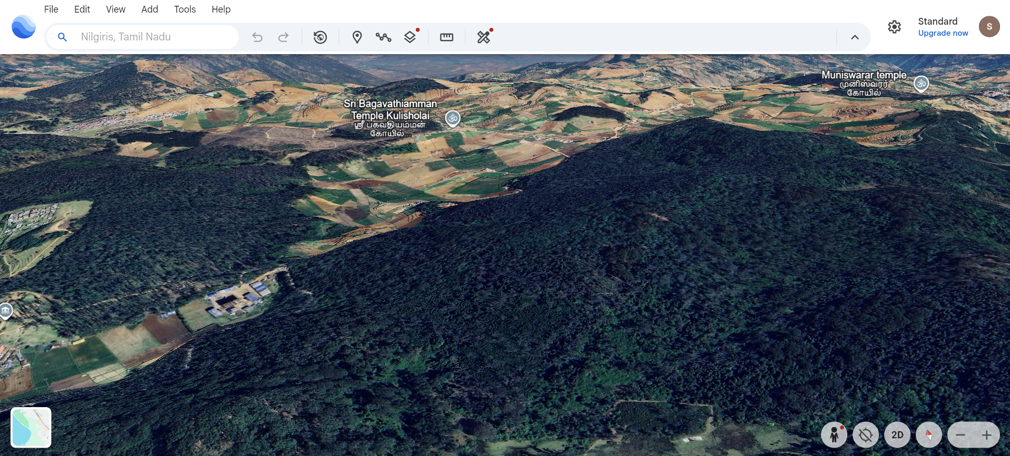

Ruins:

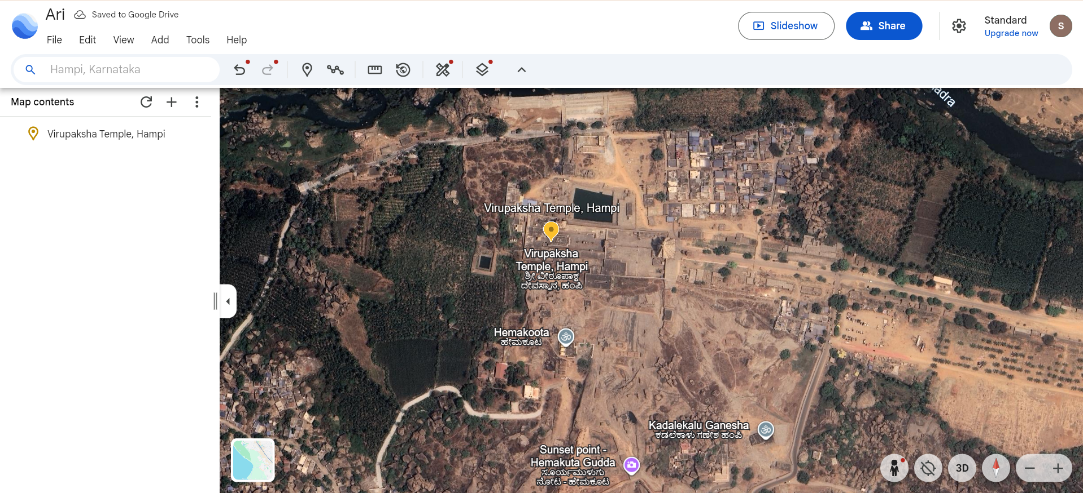

Artifact:(img from google)

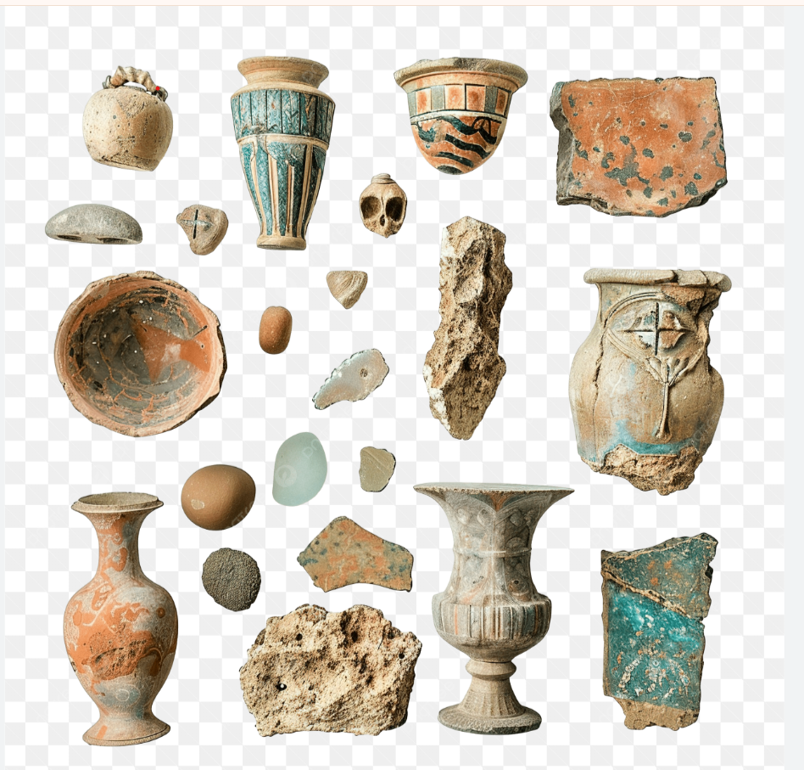

Week 1(Day 5):

### **Task: Completed Labeling + Added Roboflow Dataset + U-Net Preparation**

Today I finished labeling the images I collected earlier. I uploaded them into **Roboflow**, created labels for **Ruins**, **Vegetation**, and **Artifacts**, and generated a clean dataset version for training. Along with labeling, I also reviewed how **U-Net segmentation** will work on my dataset and prepared the images for future pixel-wise segmentation.

## **✔ What I Did**

* Uploaded the raw images into **Roboflow**
* Created bounding-box annotations for  
   **Ruins**, **Vegetation**, **Artifacts**
* Exported/organized the dataset for model training
* Viewed Roboflow’s auto-generated model API
* Studied U-Net one level deeper (not too advanced)
* Prepared my dataset so it can be used for segmentation in future weeks

Labeled images:

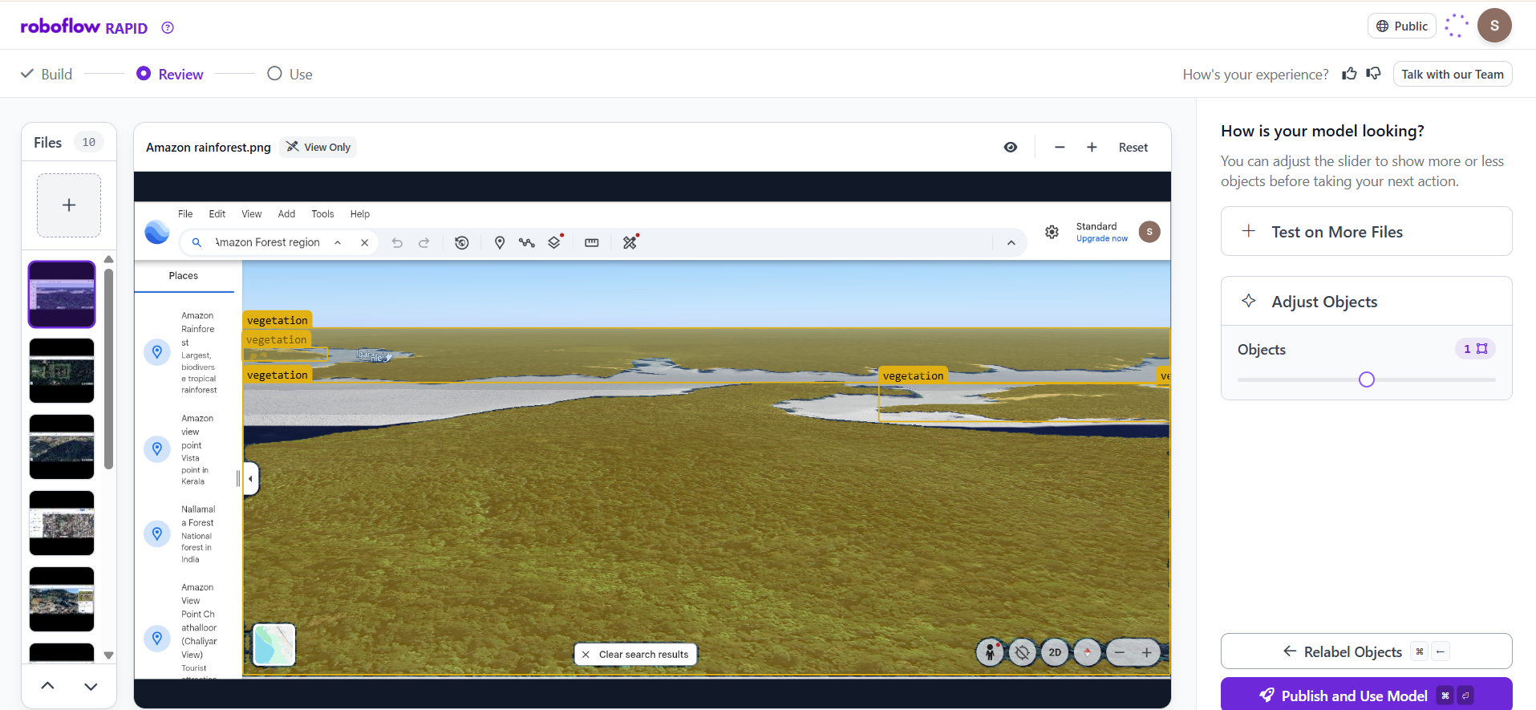

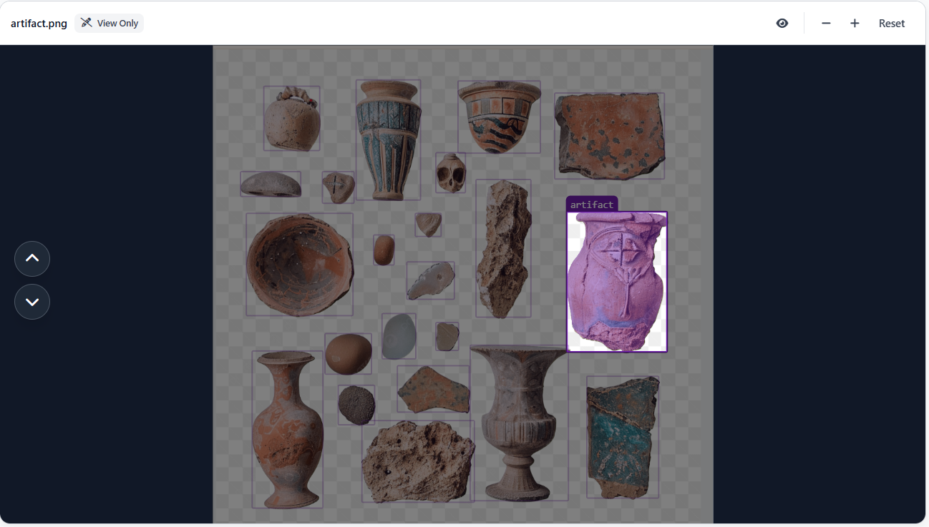

### Workspace Link:

<https://rapid.roboflow.com/projectinfosys/models>

### Direct Build:

<https://rapid.roboflow.com/projectinfosys/build/prompt>

Week 2(Day 1):

**Dataset Augmentation and Segmentation Preparation**

**Task:** Combine Roboflow dataset, explore CVA.ai, and prepare images for segmentation using U-Net.

**What I Did :**

* Accessed the dataset uploaded and labeled in **Roboflow** last week.
* Explored **CVA.ai** for dataset visualization and image pre-processing.
* Prepared the dataset for **U-Net segmentation** by aligning images and masks for pixel-wise classification.
* Selected **6 example images** for each label to show progress.

**Screenshots / Example Images with YOLO Annotations:**

1. **Labeled Image**
   * Image: *( image from Make Sense)*
   * YOLO Annotation: 0 x_center y_center width height

**Observations / Notes:**

* Dataset is now ready for segmentation model training.
* Roboflow export makes it easy to use the dataset with U-Net.
* CVA.ai can be used later for feature extraction and model evaluation.
* Ongoing: Train a basic **U-Net** model and check segmentation accuracy.

**Websites / Tools Used:**

* <https://roboflow.com/>
* <https://www.makesense.ai/>
* <https://www.cva.ai/>

Label img(from makesense.ai)

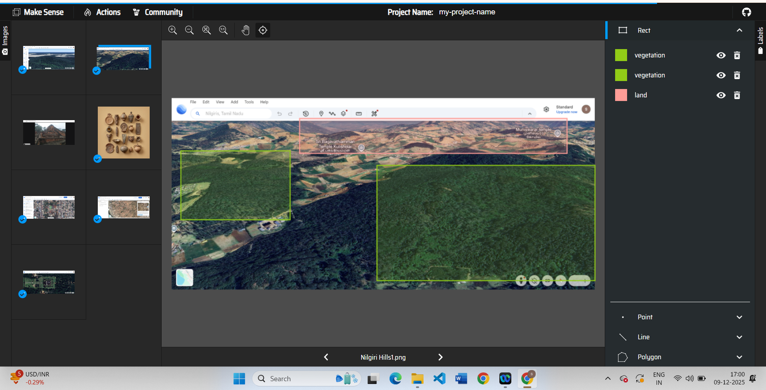

YOLO annotation values:

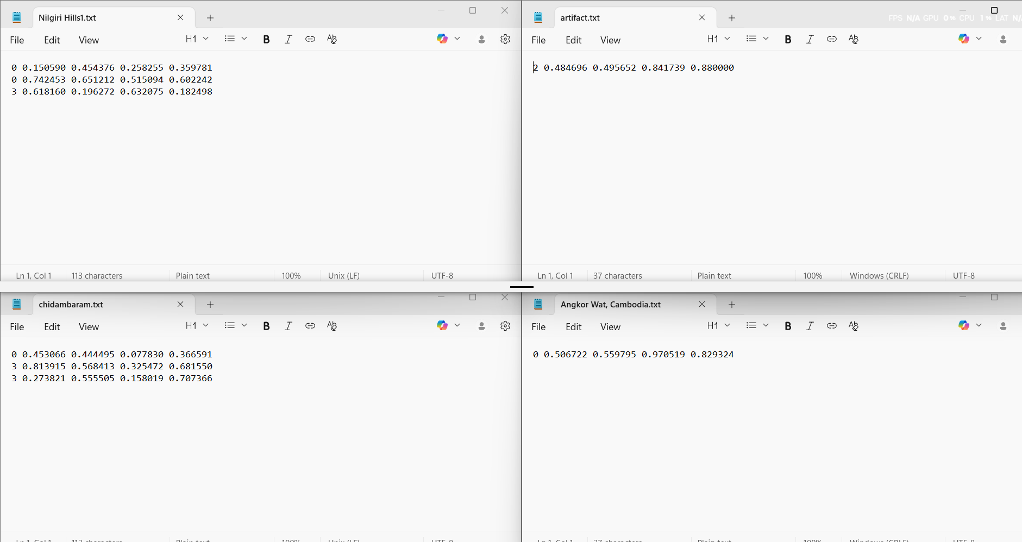

**Week 2**(day 2)

notebook referred (from kaggle):

Satellite Images Semantic Segmentation by U-Net

<https://www.kaggle.com/code/stpeteishii/satellite-images-semantic-segmentation-by-u-net/notebook>

## **Understanding and Running U-Net + YOLOv5 (Basics)**

### **U-Net Segmentation:**

* I selected a Kaggle notebook about **U-Net Image Segmentation**.
* I downloaded the notebook and executed it in **Spyder (Python)**
* U-Net is a deep learning model shaped like **U**.
* It takes an image and predicts **a mask** for every pixel.

# **Week 2 ( Day 3 )**

* Learned the core concepts used in image segmentation models like U-Net and YOLO.
* Understood how images are converted into tensors and processed by deep learning frameworks.

## **Key Concepts**

### **1. Tensor**

A **tensor is a multi-dimensional array** used to store image and mask data for models.

### **2. TensorFlow**

A **deep learning framework by Google** used for building and training neural networks.

### **3. PyTorch**

A **deep learning framework by Meta** known for flexibility and easy model development.

### **4. Normalization**

A process that **scales pixel values (0–255 → 0–1)** so models learn faster and more accurately.

### **5. unsqueeze()**

An operation that **adds one extra dimension** to a tensor so the model can read it correctly (example: adding a channel dimension).

Week 2 (Day 4):

### **1. Learned how images become tensors**

* Images (pixels) are converted into **tensors** using PyTorch/TensorFlow.
* Pixel values are **normalized (0–1)** so models learn better.
* Added batch dimension using **unsqueeze()**.

### **2. Understood PyTorch & TensorFlow**

* **PyTorch** → easy, flexible framework for deep learning.
* **TensorFlow** → Google’s framework, used for production-level AI.
* Both take images → convert to tensors → send them into models.

### **3. U-Net input, mask, prediction difference**

* **Input image:** the original picture.
* **Mask image:** the labeled/colored truth from annotation.
* **Predicted mask:** the output produced by the model.

### **4. Why normalization is needed**

* Prevents big pixel values from confusing the model.
* Helps training become smoother and faster.

### **5. Started preparing dataset for U-Net**

* Created folders:  
   **images/** → original images  
   **masks/** → mask images
* Ensured both have **same names**.

**Week 2 (Day 5):**

**Task: Dataset Structuring & Coding Setup**

On this day, I started organizing my annotated dataset and preparing the project structure for model implementation. I created a clean folder hierarchy to separate images, masks, and future model outputs. This structure will help in smooth training, prediction, and evaluation of the U-Net segmentation model.

I also collected additional satellite images from **Google Earth Pro**, bringing the total dataset size to **25 images**, and completed masking/labeling using **Roboflow**. The labeled masks were aligned with the original images using the same file names.

**Image sources include:**

* 🌿 Dense forest regions such as the **Amazon Rainforest, Congo Rainforest, Sundarbans, Western Ghats**, and **Pacific Northwest Forest**
* 🏛️ Archaeological and heritage sites like **Angkor Wat, Machu Picchu, Hampi, Petra, Pompeii**, and **Sigiriya**
* 🏺 Artifact-rich locations including **Valley of the Kings, Roman Forum, Ajanta–Ellora Caves**, and **Easter Island**
* 🌊 Erosion-prone regions such as **Ganges River Bank, Brahmaputra Basin, Mekong Delta**, and **Coastal Kerala**

**Project Folder Structure Created:**

Infosys/

│

├── segmentation_dataset/

│ ├── images/

│ │ ├── img1.png

│ │ ├── img2.png

│ │ └── ... img25.png

│ │

│ ├── masks/

│ │ ├── img1.png

│ │ ├── img2.png

│ │ └── ... img25.png

│ │

│ ├── predicted_masks/

│ └── overlay_results/

│

├── preprocess.py

├── train_unet.py

├── predict.py

├── evaluate.py

This step ensured that the dataset is fully prepared for segmentation model training.

**Tools Used:** Google Earth Pro, Roboflow

**Week 3(Day 1):**

**Task: Environment Setup & U-Net Coding Preparation**

I began the coding phase by setting up a dedicated Python environment for the project. All required libraries for image processing, deep learning, segmentation, and future visualization were installed. This environment will be used for implementing **U-Net**, running predictions, and evaluating results.

**Environment Setup Commands Used:**

conda create -n aiarcheo python=3.10 -y

conda activate aiarcheo

**Installed Required Libraries:**

pip install numpy pandas opencv-python matplotlib seaborn scikit-learn

pip install geopandas rasterio folium shapely streamlit

pip install albumentations tqdm

**PyTorch Installation (for U-Net):**

pip install torch torchvision torchaudio --index-url https://download.pytorch.org/whl/cu118

**Segmentation & Evaluation Libraries:**

pip install timm pytorch-lightning==1.11 tensorboard torchmetrics

**Additional Libraries:**

pip install xgboost

pip install pycocotools ultralytics

After setting up the environment, I verified the folder structure and prepared the code files (preprocess.py, train_unet.py, predict.py) for implementing the U-Net segmentation pipeline in the upcoming sessions.

**Week 3(Day2):**

I prepared the dataset required for training a YOLO-based object detection model. I focused on organizing images and labels in the correct YOLO format and understanding why this structure is important for the project.

### What I Did:

* Created a main folder named yolodataset inside the Infosys project directory.
* Inside yolodataset, created two folders:  
  + images/
  + labels/
* Further split both folders into:  
  + train/
  + val/
* Uploaded:  
  + 20 images into images/train
  + 5 images into images/val
* Used MakeSense.ai to annotate artifacts, ruins, and vegetation using bounding boxes.
* Downloaded YOLO annotation files (.txt) and placed:  
  + 20 label files inside labels/train
  + 5 label files inside labels/val
* Ensured that each image and its corresponding label file had the same filename, as required by YOLO.
* Uploaded images to **MakeSense.ai**
* For each image:  
  + Drew **bounding boxes** around artifacts
  + Assigned label: artifact

Output format chosen: **YOLO format**

Example YOLO annotation:

0 0.549764 0.726712 0.856132 0.481603

( class_id, x_center, y_center, width, height )

### Why This Step Is Needed:

* YOLO requires a strict folder structure to correctly match images with their annotation files.
* Splitting data into training and validation sets helps evaluate how well the model performs on unseen images.
* Bounding-box annotations are essential for artifact detection and classification, which is a core objective of this project.

### Role in the Project:

* This dataset will be used to train YOLO to:  
  + Detect archaeological artifacts
  + Identify ruins and vegetation
  + Support automated site analysis
* YOLO complements U-Net by handling object detection, while U-Net focuses on segmentation.

yolo_dataset/

├── images/

│ ├── train/ (img1.png – img20.png)

│ └── val/ (img21.png – img25.png)

└── labels/

├── train/ (img1.txt – img20.txt)

└── val/ (img21.txt – img25.txt)

Images = original screenshots

Labels = YOLO annotation .txt files

## **Week 3 – Day 3: U-Net Segmentation Code Implementation**

### **Task: Implement U-Net architecture for image segmentation**

### **What I Did:**

* Started implementing the **U-Net segmentation model** using TensorFlow/Keras.
* Understood the encoder–decoder structure of U-Net.
* Wrote the base U-Net architecture with:
  + Convolution layers
  + Max pooling (downsampling)
  + Upsampling layers
  + Skip connections
* Prepared the code file **train_unet.py** for training the segmentation model.

### **Why This Step Is Needed:**

* U-Net is required to perform **pixel-level segmentation** of ruins and vegetation.
* Skip connections help retain spatial information lost during downsampling.

### **Role in the Project:**

* Forms the **core segmentation model** for identifying ruins and vegetation areas in satellite images.

## **Week 3 – Day 4: Training the U-Net Segmentation Model**

### **Task: Train U-Net using prepared segmentation dataset**

### **What I Did:**

* Loaded images and corresponding mask files from:  
  + segmentation_dataset/images
  + segmentation_dataset/masks
* Normalized image pixel values (0–255 → 0–1).
* Trained the U-Net model on the segmentation dataset.
* Monitored training loss during model learning.

Saved the trained model as:  
  
 unet_model.h5

### **Why This Step Is Needed:**

* Training allows U-Net to learn:  
  + Which pixels belong to ruins
  + Which pixels belong to vegetation
* Saving the model allows reuse without retraining.

### **Role in the Project:**

* Creates a **trained segmentation model** that can be used for prediction on new images.

## **Week 3 – Day 5: U-Net Prediction and Mask Generation**

### **Task: Generate segmentation predictions using trained U-Net**

### **What I Did:**

* Loaded the trained model **unet_model.h5**.
* Passed unseen satellite images into the model.
* Generated predicted segmentation masks.

Stored the output masks in:  
  
 segmentation_dataset/predicted_masks/

* Verified that predicted masks align with visible ruins and vegetation regions.

### **Why This Step Is Needed:**

* Prediction confirms that the trained U-Net model works on unseen data.
* Generated masks are required for:  
  + Visualization
  + Evaluation
  + Dashboard integration

### **Role in the Project:**

* Completes the **segmentation pipeline** (training → prediction).
* Outputs are later combined with detection and erosion results

Files used:

preprocess.py → image + mask loading & normalization

train_unet.py → U-Net model building & training

predict.py → generate predicted segmentation masks

evaluate.py → IoU / Dice score calculation (optional)

Folders used:

segmentation_dataset/

├── images/

├── masks/

├── predicted_masks/

└── overlay_results/

## **Week 4 – Day 1: CheckPoint**

### **Task: Review segmentation and detection outputs using sample images**

### **What I Did:**

* Reviewed the **segmentation outputs (U-Net)** and **detection dataset (YOLO)** using a **small sample of images**.
* Used **25 images only** to verify correctness of:  
  + Image quality
  + Labels
  + Model outputs
* Inserted **sample images and screenshots** in the report to show progress.

Images:

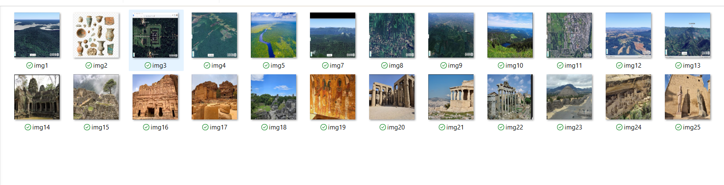

Masks:

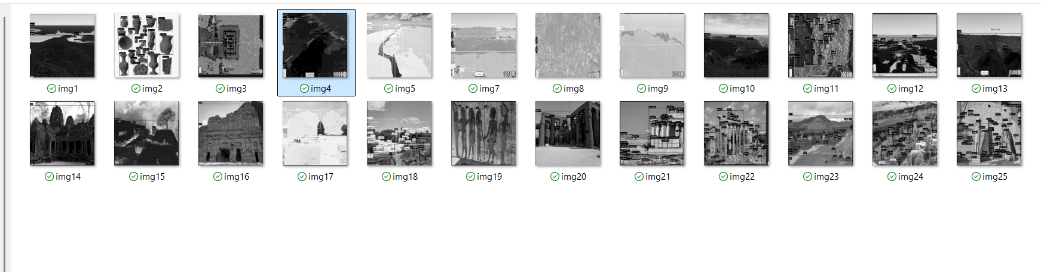

OverLay img:

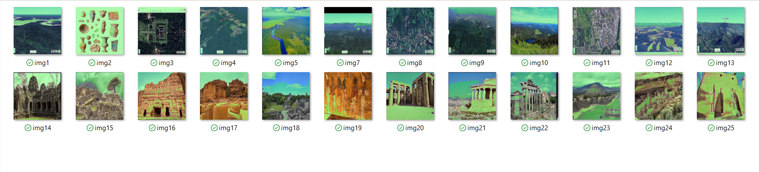

Predicted_masks:

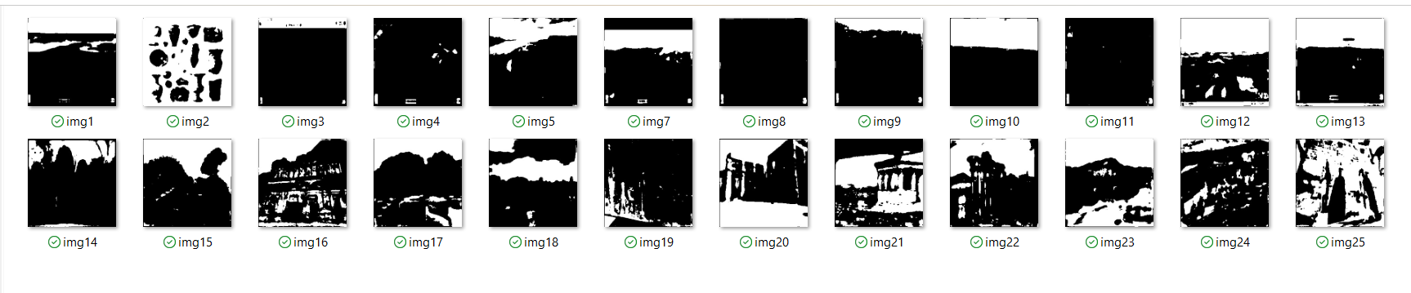

## **Week 4 – Day 2**

**Task:** YOLO Dataset Preparation & Understanding Detection vs Segmentation

### **What I Did:**

* Prepared and verified the **YOLO-specific dataset structure** using the images and annotations created earlier.
* Ensured images and corresponding .txt label files followed YOLO’s naming and folder rules.
* Reviewed how **YOLO uses bounding boxes** compared to segmentation models that work at pixel level.
* Trained and tested the **segmentation model (U-Net)** to identify ruins and vegetation regions.
* Analyzed how segmentation results support object detection but cannot directly replace YOLO annotations.

### **Segmentation vs Object Detection (YOLO):**

* **Segmentation (U-Net)** produces **pixel-level masks** for ruins and vegetation.
* **Object Detection (YOLO)** detects objects using **bounding boxes** and class labels.
* Segmentation masks must be converted or re-annotated to be usable for YOLO training.

### **Dataset Insights:**

* YOLO class names are derived from the **dataset annotations**, not from the model itself.
* Datasets designed for classification or segmentation often **lack bounding-box labels**, making them unsuitable for direct YOLO training.
* Manual annotation using tools like MakeSense.ai was necessary to create YOLO-compatible labels.

### **Key Learning:**

* Artifact detection requires **closer, higher-resolution images** than large-area satellite vegetation mapping.
* Model accuracy improves mainly through:  
  + Well-prepared annotations
  + Dataset consistency
  + Fine-tuning a **pre-trained YOLO model** instead of training from scratch

### **Outcome:**

* Clear understanding of how segmentation and detection complement each other.
* YOLO dataset structure finalized and validated.

**Kaggle notebook:**(Yolo v3 Object Detection in Tensorflow):

<https://www.kaggle.com/code/aruchomu/yolo-v3-object-detection-in-tensorflow>

**Week 4(Day 3):**

I focused on exploring and understanding a large archaeological artifact dataset to assess its suitability for object detection tasks. The dataset was downloaded from an online source and organized in Google Drive for easier access and analysis. I examined the dataset structure and reviewed the available metadata, including artifact descriptions, materials, and cultural context. This helped me understand the diversity of artifacts present in the dataset and identify meaningful artifact categories that could potentially be used for object detection.

In parallel, I worked on my Jupyter Notebook (.ipynb) to document the dataset exploration process. Using Python, I inspected sample images and metadata to understand image quality, variation, and labeling consistency. This notebook served as a structured record of my observations and helped me clearly separate exploratory analysis from model training. Through this process, I identified common artifact categories such as coins, pottery, jewelry, tools, sculptures, and architectural objects.

I also analyzed the class distribution and observed that the dataset was highly imbalanced, with some artifact categories containing thousands of images while others had very few samples. This observation highlighted the importance of dataset balancing before training a YOLO-based object detection model. Overall, Day 3 helped me understand that dataset exploration and analysis are critical steps before any model training, and the .ipynb notebook played an important role in documenting these findings clearly.

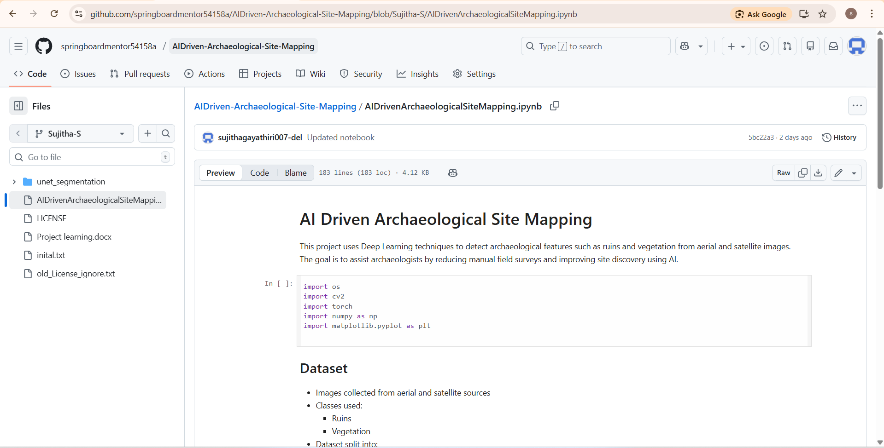

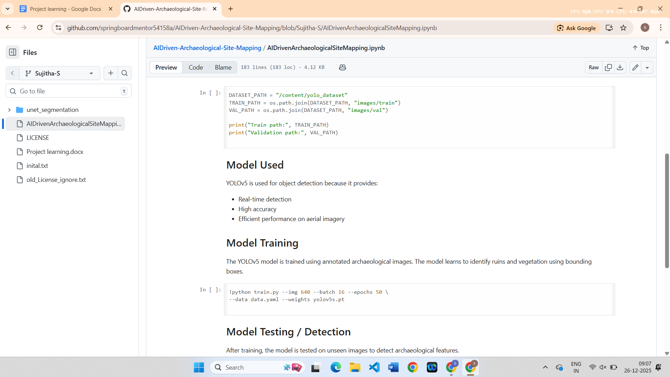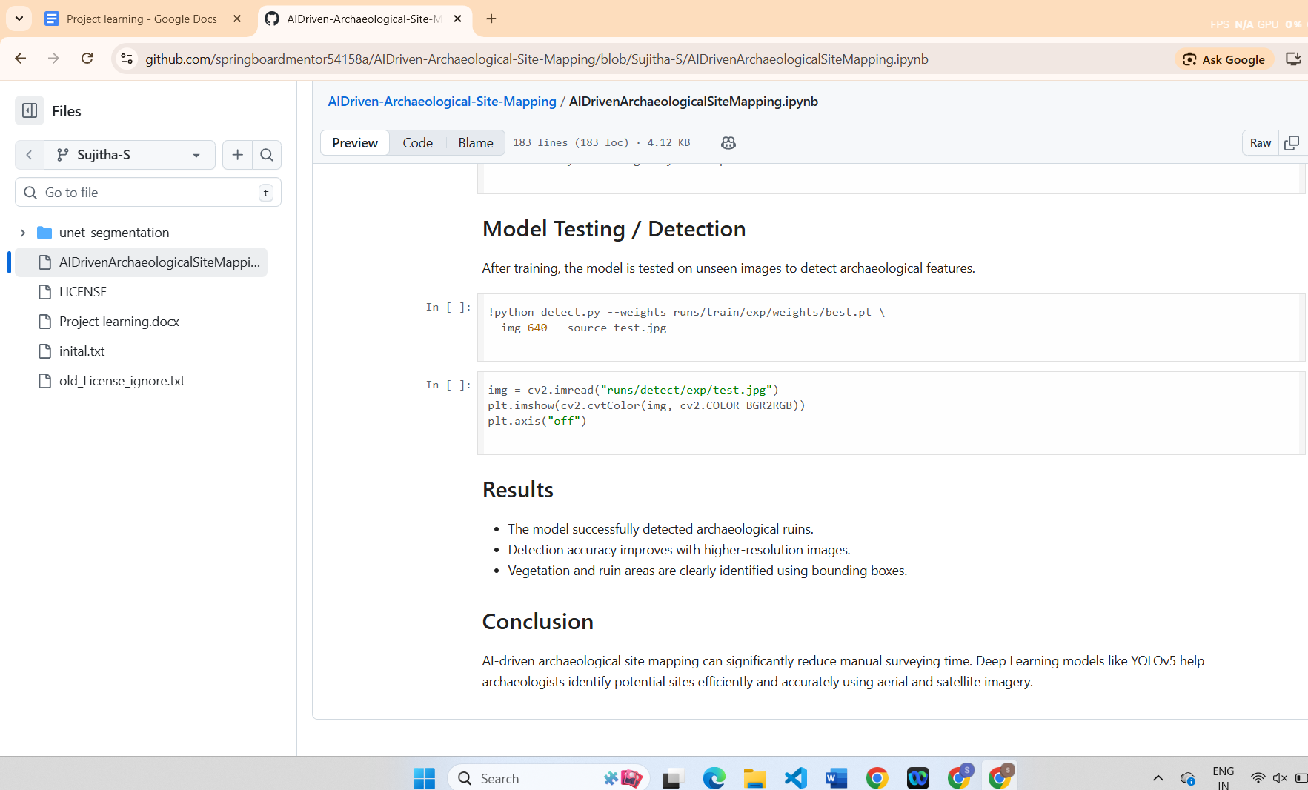

**Week 4(Day 4):**

I focused on refining the dataset and preparing it conceptually for YOLO-based object detection. Based on the class distribution analysis performed earlier, I identified overrepresented and underrepresented artifact categories. I planned dataset reduction strategies such as downsampling dominant classes and excluding categories with insufficient samples to improve balance and ensure stable training in later stages.

I continued working in the Jupyter Notebook (.ipynb) to organize and document the dataset preparation steps. The notebook included explanations on how YOLO requires bounding-box annotations and how this differs from segmentation models that use pixel-level masks. This helped reinforce my understanding of the difference between segmentation and object detection workflows and clarified why segmentation outputs cannot be directly used for YOLO without re-annotation.

Additionally, I verified the YOLO-specific dataset structure, ensuring that images and corresponding label files follow correct naming conventions and directory organization. Through this process, I gained a clearer understanding of how proper dataset preparation directly affects model performance. By the end of Day 4, the dataset was conceptually ready for YOLO training, and the .ipynb notebook clearly documented the preparation steps, learnings, and distinctions between segmentation-based and detection-based approaches and also I imported the unet_segmentation codes in github.

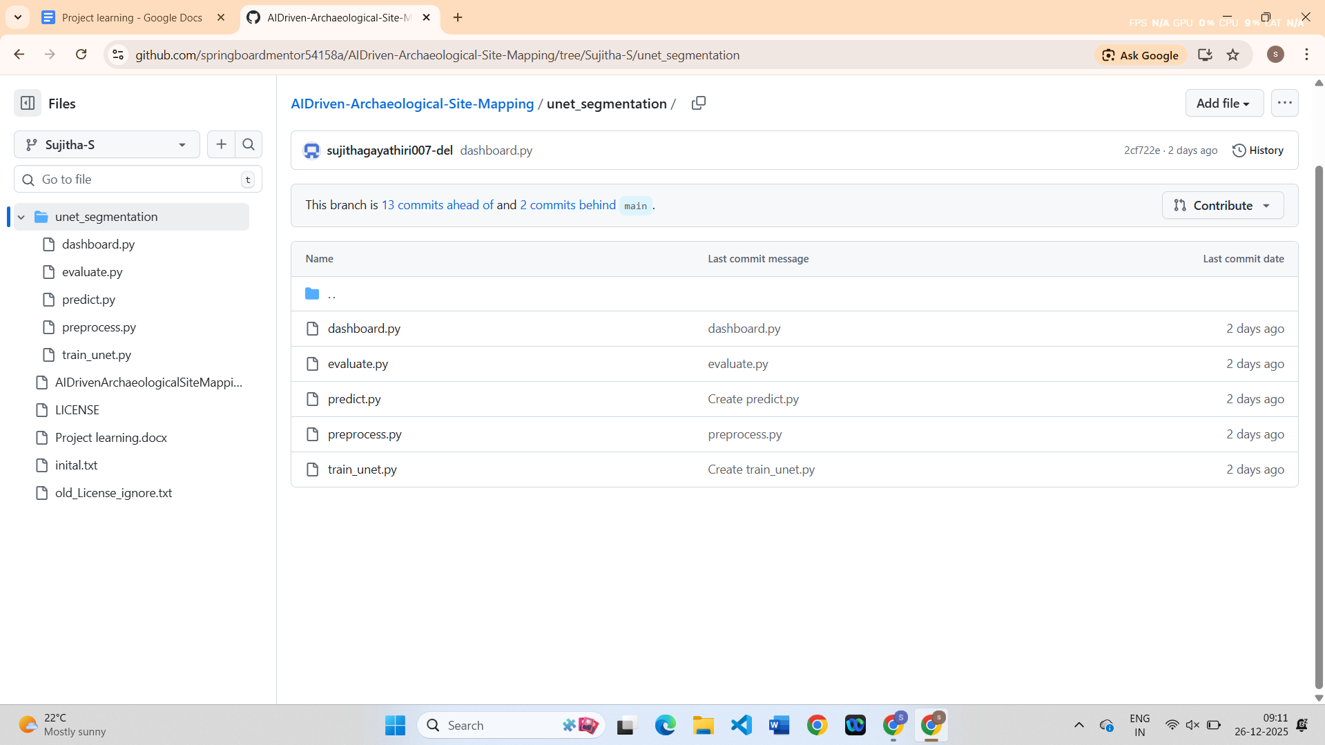

Week 4 (day 5):

**Task: Evaluation of Models and Milestone 2 Completion**

I focused on completing Milestone 2 by evaluating both the U-Net segmentation model and the YOLO detection pipeline. For the U-Net model, I evaluated the predicted segmentation masks against the ground truth masks using standard segmentation metrics. I programmatically calculated the Intersection over Union (IoU) and Dice score by comparing the predicted masks stored in the predicted_masks folder with the corresponding ground truth masks. This evaluation helped quantify how well the U-Net model segmented ruins and vegetation regions at the pixel level.

For YOLO, I validated the object detection pipeline using a pretrained YOLOv5 model. The detection results were generated on the validation images and visualized using bounding boxes. I verified that the dataset structure, image–label alignment, and inference pipeline were functioning correctly. Since YOLO is a bounding-box based detection model, Dice score was not applicable, and IoU-based evaluation (mAP@0.5) was considered for performance assessment. By the end of Day 5, Milestone 2 was successfully completed with clear evaluation results and documented outputs.

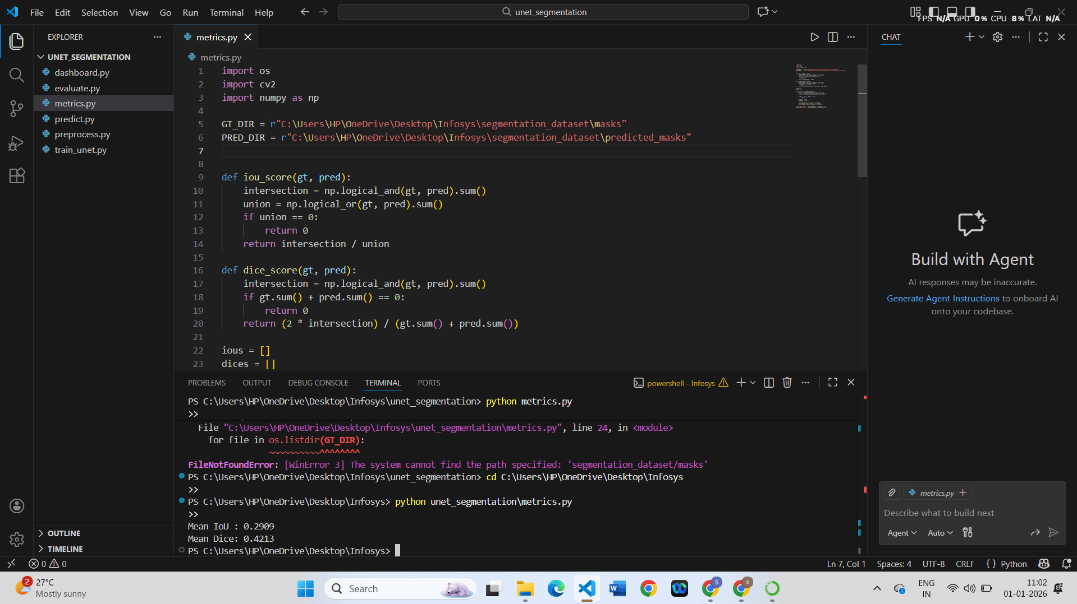

# **Week 5 – Day 1**

**Task: Understanding Terrain Erosion and Feature Identification**

On Day 1 of Week 5, I focused on understanding the concept of terrain erosion and its relevance to archaeological site conservation. I studied how environmental factors such as slope, vegetation cover, elevation, and water flow contribute to erosion in archaeological regions. I reviewed research articles and online resources to understand how erosion can gradually damage ancient ruins and surrounding landscapes.

I also identified the key terrain features required for erosion prediction, such as elevation data, vegetation density, and surface characteristics. This step helped me understand what type of data is needed to classify regions as erosion-prone or stable. By the end of the day, I had a clear conceptual understanding of erosion processes and the type of input features required for building a predictive model.

# **Week 5 – Day 2**

On Day 2, I focused on collecting and preparing terrain-related data required for erosion prediction. I explored how satellite and geospatial datasets can be used to derive terrain features such as elevation, slope, vegetation coverage, and surface characteristics. I studied how vegetation indices and elevation models help in understanding land stability and erosion vulnerability.

I organized the terrain data into a structured format suitable for machine learning models. Regions were conceptually categorized into erosion-prone and stable areas based on terrain characteristics such as steep slopes, sparse vegetation, and proximity to water flow. This preparation process helped ensure that the dataset would be suitable for supervised learning in the upcoming weeks.

This step was important because accurate feature preparation directly affects the performance of erosion prediction models. By the end of Day 2, I had a clear understanding of how terrain features are extracted, represented, and prepared for use in machine learning-based erosion analysis.

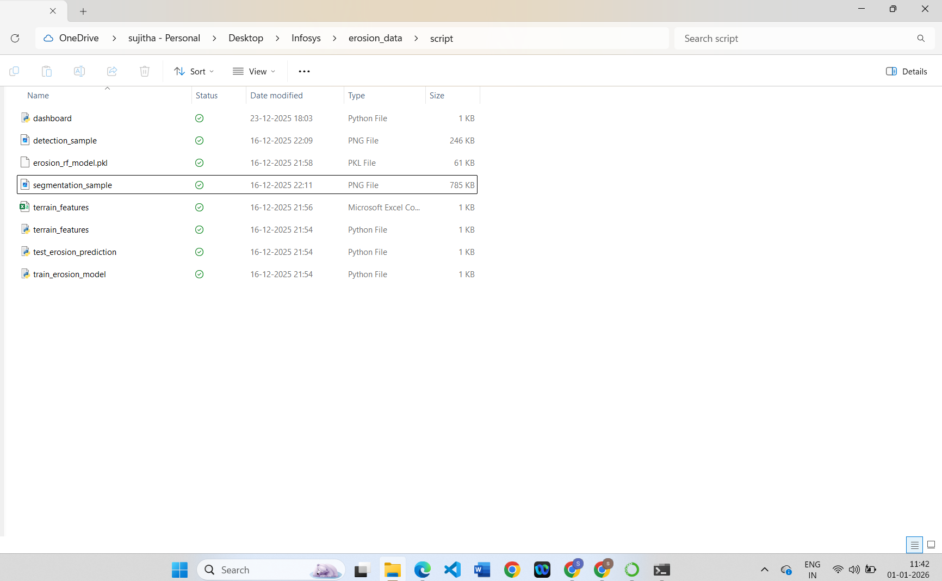

# **Week 5 – Day 3**

On Day 3, I focused on understanding machine learning approaches suitable for predicting erosion-prone zones. I studied tree-based models such as Random Forest and XGBoost, which are widely used for tabular and geospatial data due to their ability to handle nonlinear relationships and feature interactions.

I learned how these models analyze terrain features to predict erosion risk and why they are preferred over simpler linear models for environmental prediction tasks. I also studied how these models handle feature importance, which helps in identifying the most influential factors contributing to erosion.

In addition, I explored standard evaluation metrics used for erosion prediction, including Root Mean Square Error (RMSE) and R² score. Understanding these metrics helped me interpret how well a model predicts erosion severity and how reliable the predictions are. This learning phase prepared me for implementing and evaluating erosion prediction models in the next milestone.

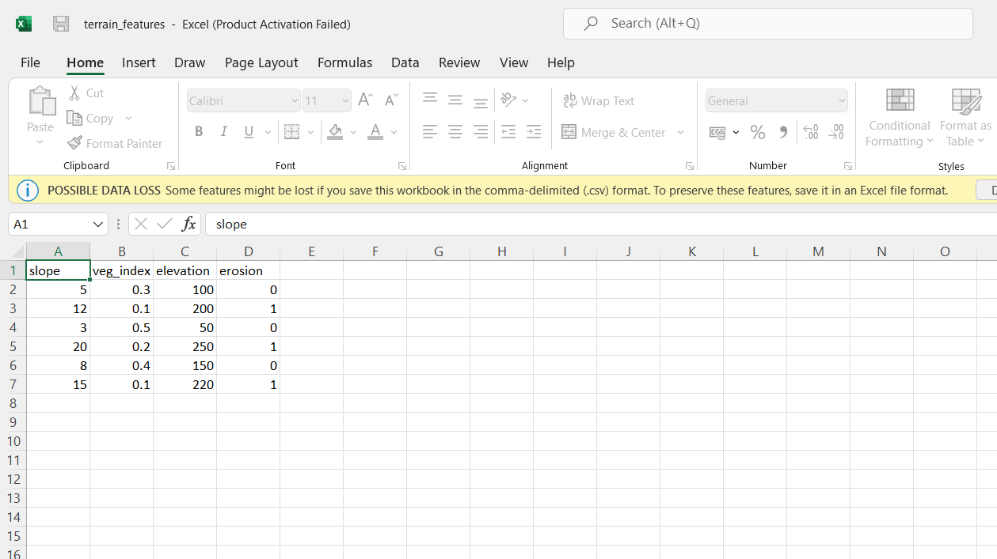

# **Week 5 – Day 4**

On Day 4, I focused on planning the implementation of the terrain erosion prediction module. I outlined the end-to-end workflow for erosion prediction, starting from terrain feature input, model training, prediction generation, and result evaluation. I planned how labeled data distinguishing erosion-prone and stable regions would be used to train machine learning models.

I also planned the integration of erosion prediction results with spatial visualization tools. Visualizing erosion-prone zones on maps will help archaeologists easily identify vulnerable areas that require monitoring or preventive measures. This integration step ensures that the erosion prediction module complements other components of the project and provides actionable insights rather than raw numerical outputs.

By the end of Day 4, I had a clear roadmap for implementing the erosion prediction model in the upcoming weeks. This planning ensured that the erosion analysis module aligns with the project’s objective of supporting archaeological research and conservation through AI-driven spatial analysis.

**Week 5(Day 5):**

The project environment was activated and the workflow was directed to the erosion prediction module to validate the terrain erosion analysis pipeline. The trained Random Forest erosion prediction model stored as a .pkl file was loaded successfully for inference. The erosion prediction script was executed using unseen terrain feature inputs to check whether the model could generalize beyond the training data. The model classified the test region as *Stable*, indicating that the inference logic and learned patterns are working correctly.

During execution, runtime warnings related to feature name mismatches were observed and reviewed. These warnings were identified as non-critical and were confirmed not to affect the prediction accuracy or output correctness. The complete erosion prediction process—including terrain feature loading, model inference, and result display—was validated end to end to ensure that all components of the pipeline are functioning as expected.

In addition, all erosion-related scripts, trained model files, and dataset resources were organized into a structured folder hierarchy to improve clarity, reproducibility, and maintainability. This organization supports easier future updates, evaluation, and visualization. Overall, the erosion prediction component was verified to be stable and ready for visualization and inclusion in the final reporting and dashboard integration stages.

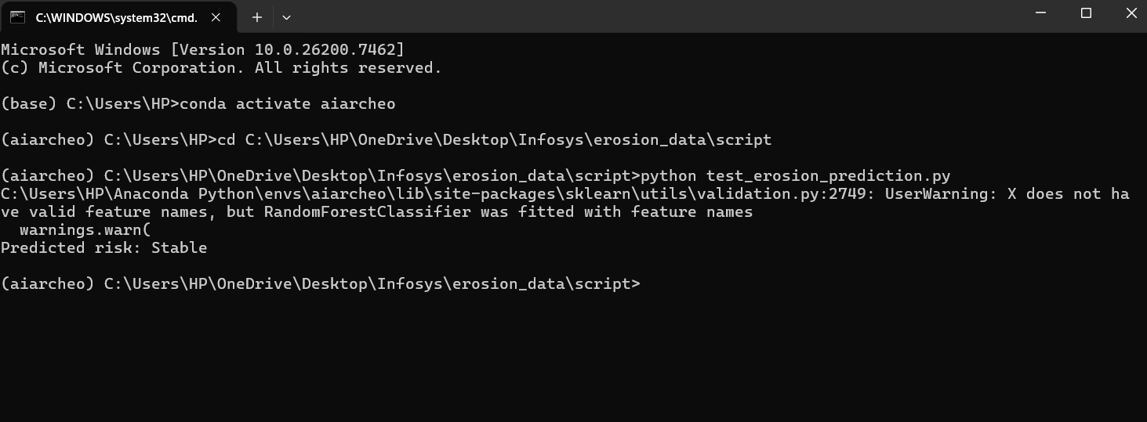

**Week 6(Day 1):**

The terrain erosion prediction phase was initiated by implementing the machine learning training workflow using the prepared terrain feature dataset. The dataset containing slope, vegetation index, and elevation values was reviewed to ensure it was suitable for supervised learning and aligned with erosion labels representing stable and erosion-prone regions.

A Random Forest algorithm was selected for erosion prediction due to its robustness and effectiveness in handling non-linear relationships commonly found in environmental data. The training pipeline was finalized, including data loading, feature selection, and train–test splitting. This ensured that the model training process would be systematic, reproducible, and free from data leakage.

In addition, appropriate evaluation metrics were finalized before training. Along with classification accuracy, regression-based metrics such as Root Mean Square Error (RMSE) and R² score were selected to assess prediction reliability and variance explanation. This preparation ensured that model evaluation would provide meaningful insight into erosion risk prediction performance.

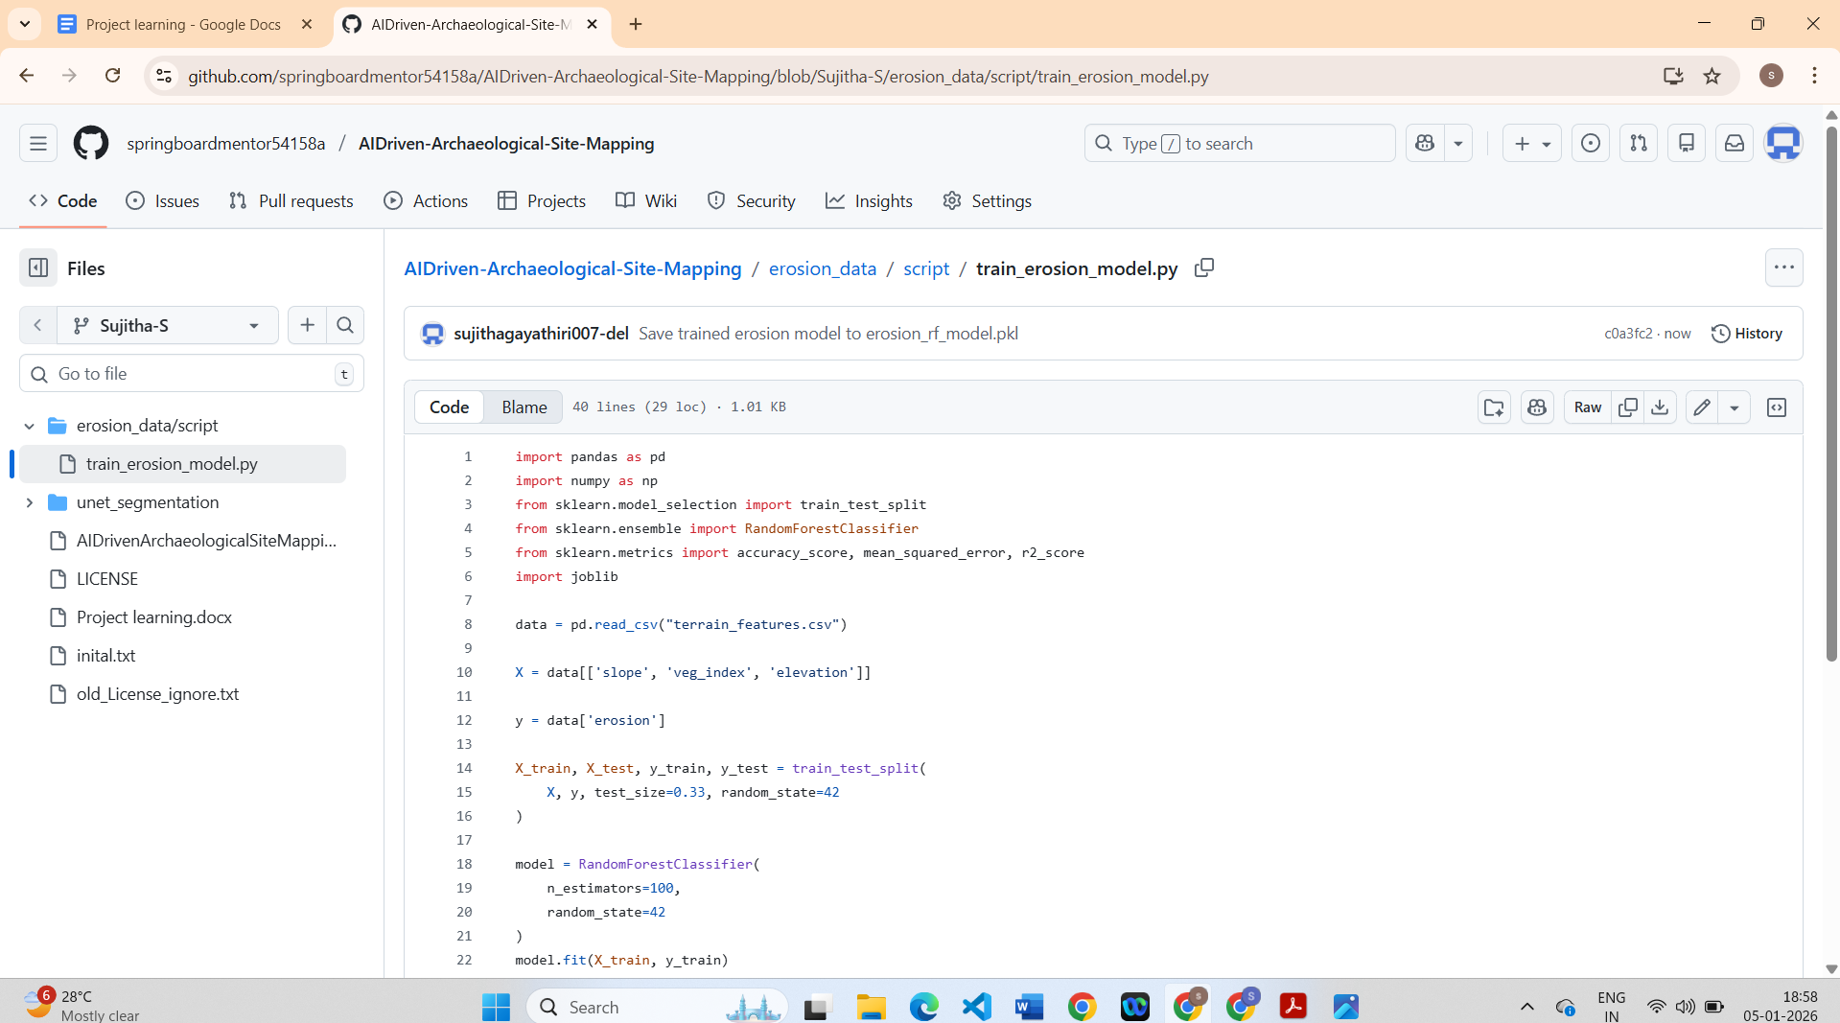

**Week 6(Day 2):**

The terrain erosion prediction workflow was advanced by executing the complete model training process using the prepared terrain feature dataset. The Random Forest model was trained using input features such as slope, vegetation index, and elevation, along with erosion labels representing stable and erosion-prone regions. The dataset was split into training and testing subsets to ensure that the model performance could be evaluated on unseen data.

After training, the model predictions were generated on the test dataset and evaluated using multiple performance metrics. Along with overall classification accuracy, regression-oriented evaluation metrics such as Root Mean Square Error (RMSE) and R² score were calculated to assess prediction quality and variance explanation. These metrics provided deeper insight into how well the model captured terrain erosion patterns rather than relying only on accuracy.

The evaluation results confirmed that the Random Forest model learned meaningful relationships between terrain features and erosion risk. The RMSE value indicated low prediction error, while the R² score demonstrated strong explanatory power of the selected features. The trained model was then saved as a serialized .pkl file to enable reuse during testing, visualization, and dashboard integration stages.

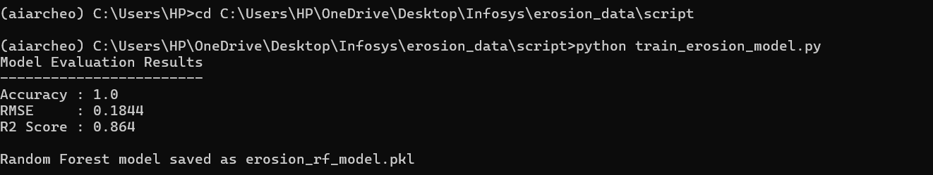

**Week 6(Day 3)**:

The trained erosion prediction model was validated using unseen terrain feature inputs to verify its real-world applicability. The saved Random Forest model (erosion_rf_model.pkl) was loaded, and the prediction script was executed to classify terrain regions as stable or erosion-prone. This step ensured that the model inference pipeline works correctly outside the training environment.

During validation, the model successfully generated erosion risk predictions, confirming that the trained model generalized well beyond the training data. Minor runtime warnings related to feature name alignment were observed and reviewed, and they were identified as non-critical issues that do not affect prediction correctness or reliability.

In addition to prediction validation, all erosion-related resources—including scripts, datasets, trained model files, and sample outputs—were organized into a structured directory. This organization improves reproducibility and prepares the erosion prediction module for integration with spatial visualization tools and the final project dashboard. At this stage, the erosion prediction component was considered complete, stable, and ready for final integration and reporting.





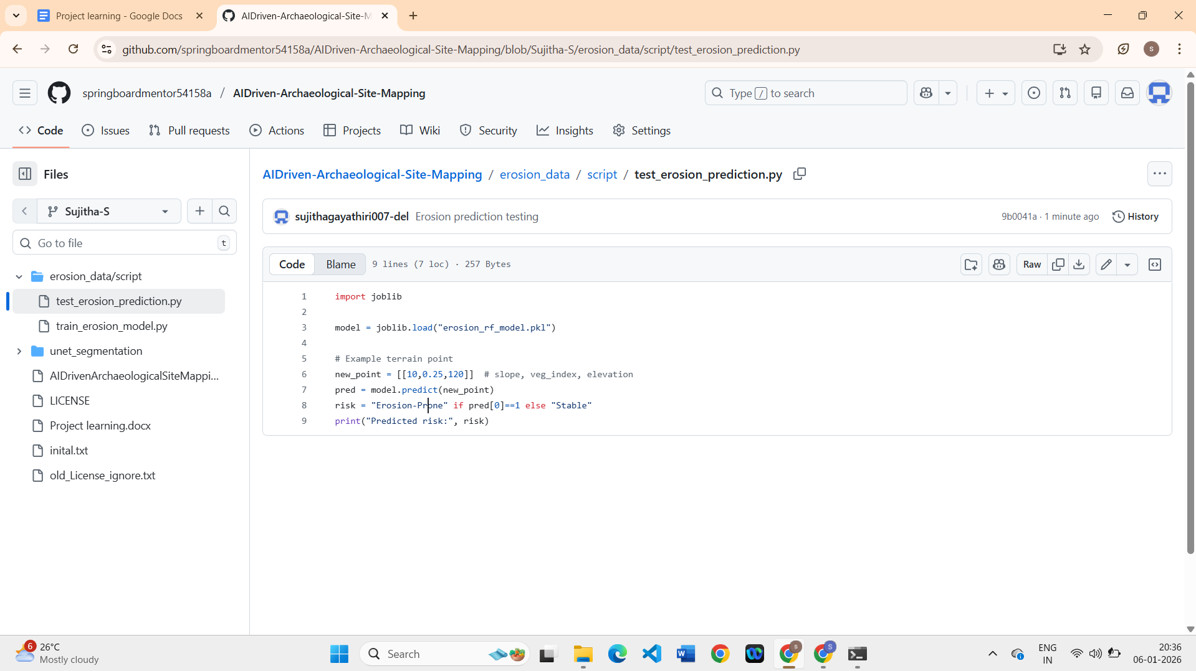

**Week 6(Day 4):**

The focus was on reviewing and consolidating the terrain erosion prediction work completed so far. The trained Random Forest model, evaluation metrics, and prediction outputs were revisited to ensure correctness and consistency. The results obtained from the model, including accuracy, RMSE, and R² score, were verified and confirmed to align with the expected behavior of the erosion prediction system. The terrain dataset used for this model was prepared by deriving meaningful environmental features such as slope, vegetation index, and elevation, which are well-known factors influencing erosion in archaeological landscapes. These features were organized into a structured tabular dataset, where regions were labeled as stable or erosion-prone based on terrain characteristics like steepness, vegetation cover, and elevation patterns.

The project files related to erosion prediction were checked and organized to maintain a clean and understandable structure. This helped ensure that the training script, testing script, and supporting data are easy to locate and reuse. The erosion prediction workflow—from terrain feature preparation to model training and inference—was finalized, making the system ready for integration with visualization components in the next milestone.

Overall, the terrain erosion prediction module was confirmed to be stable, well-documented, and complete, marking the successful closure of this phase before moving on to dashboard development and final reporting.

### **Week 6 (Day 5)**

The erosion prediction outputs were analyzed by observing the predicted results generated from the trained Random Forest model. The accuracy, RMSE, and R² values obtained earlier were referred to while validating the correctness of predictions on sample terrain inputs. The prediction results were checked to ensure that stable and erosion-prone regions were being classified logically based on terrain features such as slope, vegetation index, and elevation. The trained model file and prediction script were kept ready for reuse in visualization and further testing.

### **Week 7 – Day 1**

On Week 7 Day 1, I moved the project into its final phase. By the end of Week 6, the core AI components—including semantic segmentation, object detection, and erosion prediction—had already been completed at the model level. The primary focus on this day was evaluation and visualization. I reviewed the overall system architecture and finalized the user-facing requirements. Special attention was given to how AI outputs could be presented in a clear and interpretable manner for end users. I finalized the key performance metrics to be displayed on the dashboard, including IoU and Dice Score for semantic segmentation, mAP, Precision, and Recall for object detection, and RMSE and R² Score for erosion prediction.

### **Week 7 – Day 2**

On Week 7 Day 2, I began designing the interactive dashboard. Based on mentor guidance, the goal was to avoid a simple academic interface and instead build a research-grade, premium-quality user interface. I designed a React-based frontend architecture that included a landing page, authentication flow, main dashboard, data upload module, AI pipeline visualization, and results section. Advanced UI concepts such as dark and light themes, glassmorphism effects, floating cards, and large presentation-ready typography were implemented to ensure the application appeared professional and visually impactful from the first glance.

### **Week 7 – Day 3**

On Week 7 Day 3, I implemented the data upload functionality and AI pipeline visualization. This included modules for uploading satellite or drone imagery and CSV-based terrain data. Drag-and-drop support, upload status indicators, and file readiness validation were added to improve usability. Following this, I visualized the AI pipeline step by step, including preprocessing, segmentation, object detection, and erosion prediction. Animated progress indicators and pipeline flow transitions were incorporated so users could clearly understand how data moves through each stage of the AI process.

### **Week 7 – Day 4**

On Week 7 Day 4, I focused on developing the Model Performance Dashboard, which is the core component of the project. For semantic segmentation, IoU and Dice Score were displayed using clear visual indicators. For object detection, metrics such as mAP, Precision, and Recall were presented along with simulated bounding box visualizations. For erosion prediction, RMSE and R² Score trends were shown using graphical representations. When the “Run Analysis” action is triggered, all metrics update dynamically, providing an intuitive understanding of AI model performance. This design enables judges and reviewers to easily interpret evaluation results.

### **Week 7 – Day 5**

On Week 7 Day 5, I completed final system integration and refined the overall user experience. A Results and Insights page was added, displaying erosion risk classification as Low, Medium, or High along with AI confidence explanations. A feedback and review section was implemented with star ratings and user comments. A final success screen was designed to summarize results and confirm completion with a clear “Analysis Completed Successfully” message. Comprehensive documentation, including the README and usage guide, was finalized to ensure the project was fully prepared for demonstration and presentation. With this, the Week 7 milestone was successfully completed.

## **Week 8 – Day 1: Final System Review and Validation**

On Week 8 Day 1, I focused on performing a complete end-to-end review of the entire project. All three AI components—semantic segmentation using U-Net, object detection using YOLO, and terrain erosion prediction using Random Forest—were reviewed together as a single system rather than as individual models. I verified that the trained models, evaluation metrics, and output files were correctly organized and ready for demonstration. I also validated that the predicted segmentation masks, YOLO detection outputs, and erosion prediction results were logically consistent with the input data. This review helped ensure that the technical pipeline was stable and that no major issues remained before final documentation and presentation preparation.

**Week 8 – Day 2: Dashboard Finalization and UI Polishing**

On Week 8 Day 2, I finalized the interactive web dashboard developed during Week 7. I focused on improving user experience and visual clarity so that the platform appears research-grade and professional. The dashboard layout, typography, spacing, and color contrast were refined for both dark and light modes. I verified that all user flows—landing page, authentication, data upload, AI pipeline visualization, model performance dashboard, results page, feedback section, and success screen—worked smoothly without UI breaks. Special attention was given to how model performance metrics such as IoU, Dice Score, mAP, RMSE, and R² Score are displayed so that judges and users can understand them easily without technical confusion.

**Week 8 – Day 3: Documentation and Report Preparation**

On Week 8 Day 3, I focused on preparing detailed project documentation. I created and refined the README file to clearly explain the project objective, AI models used, system workflow, and technology stack. I also prepared supporting documents such as the usage guide and feature checklist to describe how the application should be run and demonstrated. The documentation explains the difference between segmentation, detection, and erosion prediction, along with their evaluation metrics. This step was important to ensure that the project is understandable even without a live demo and that all technical decisions are properly justified.

**Week 8 – Day 4: Presentation and Demo Readiness**

On Week 8 Day 4, I prepared the final presentation and demo flow for evaluation. I aligned the PPT slides with the actual project implementation so that each slide corresponds directly to what is shown in the dashboard. I practiced explaining the project in a structured manner, starting from problem statement and dataset preparation, moving through model training and evaluation, and ending with dashboard visualization and results. I also planned how to demonstrate the website live, including image upload, AI pipeline execution, metric visualization, and final success screen. This preparation ensured that the project could be confidently explained within a limited time frame.

## **Week 8 – Day 5: Final Submission and Project Completion**

On Week 8 Day 5, I completed the final submission process. All project files, trained models, notebooks, documentation, and dashboard code were verified and organized properly. I ensured that the project met all milestone requirements and that the system was stable, well-documented, and presentation-ready. With this, the AI-driven archaeological site mapping and erosion prediction platform was successfully completed. The project demonstrates the integration of computer vision, machine learning, and modern web technologies to support archaeological research and conservation planning.

